Hot House is a free & confidential alcohol and drug service for people (under 25) & their family or friends.

What happens at the Hot House?

- You will meet with a counsellor (for about 1 hour) who will ask about lots of things like drinking and drugs, moods, relationships, work, study, etc, to try to understand how you are coping and how alcohol or drugs fit in your life.
- You will be asked to fill out a ‘Registration Form’ which has your contact details. We also ask you to fill in a few other forms to help us see how you are going and ways we might be able to help.
- 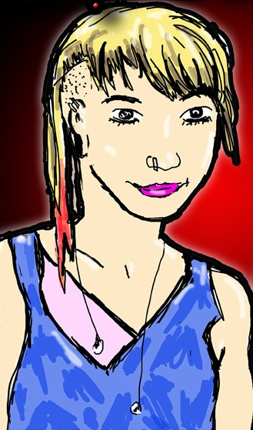Your counsellor will ask about goals. Together you will come up with a plan about how to achieve these goals. This will include whether you will come back and for how many sessions, the things you might talk about and, ways to keep safe and reduce harms
- Being here is voluntary … It is your choice to come here or to come back
YSCS HADS BROCHURE v1.0 (2014)
Services available
- Alcohol & drug assessment and treatment from a team of trained Social Workers and Psychologists.
- We can help you to link up with other services too, such as mental health, sexual health, doctors, youth services, detox and rehab.

Confidentiality
All information about you remains confidential with this service. We don’t let others know you are here or what you talk about except if:
- you sign a ‘consent form’ or give permission for us to talk with other people,
- you or someone else is at high risk of being hurt. This is also called our ‘duty of care’,
- a court orders us to give information to them about you (this is very, very rare),
- your GP requests information to help them provide medical help with you.
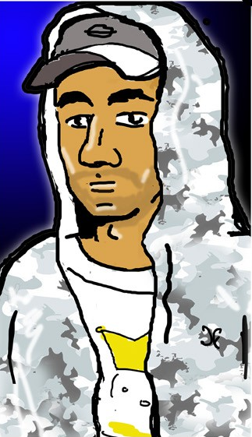We do talk about your goals and plans with other Hot House team members. This is done to make sure you receive the best care available.
We also keep notes (a medical record) about your time here, which is stored in a safe and secure place.

Value & respect
Hot House is a non-judgemental place, and we respect and value all people who come to our service. We ask that you:
- respect the privacy and confidentiality of others who are here,
- turn up ‘straight’, otherwise you might be asked to leave (and return another time),
- remain calm. Threats, yelling and aggression aren’t okay here,
- celebrate diversity. Racist, sexist, or homophobic jokes and comments are not welcome, and
- call and let us know if you can’t make it ASAP, so others can use the appointment time. We can make another time if you would like that.

Can my parents, partner or friend come along?
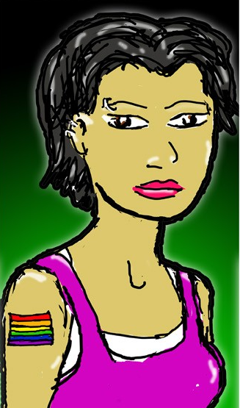Family, parents and friends are welcomed here as well. They can see a counsellor with you or a different counsellor if you would prefer. It is still confidential.
Having support people involved can make things better – even if you are not getting along with them right now.

We value your feedback

We want to provide the best care & help we can. Let us know when we get it right or could get it better. You can give feedback to your counsellor, or fill out an anonymous feedback form (in the reception area).

Attendance letter or reports
Ask your counsellor if you need a letter or report saying you are coming along here. A letter listing times you attended is free. A more detailed report (e.g. for court) costs a fee. You or your lawyer need to write a letter asking for a report to be written, and a minimum of 2 weeks notice is needed. Ask your counsellor for details.

Crisis or after hours help
ADIS - Alcohol & Drug Info Service
24/7 telephone counselling, information & referral. Freecall 1800 177 833

Kids Help Line
24/7 telephone counselling for young people under 25. Freecall 188 55 1800

Medical emergency – Call 000
If someone drops, is unwell or freaking out, call an ambulance immediately. Don’t leave them alone as help is vital at this time.

Counselling Online
24/7 online alcohol and drug counselling.
www.counsellingonline.org.au

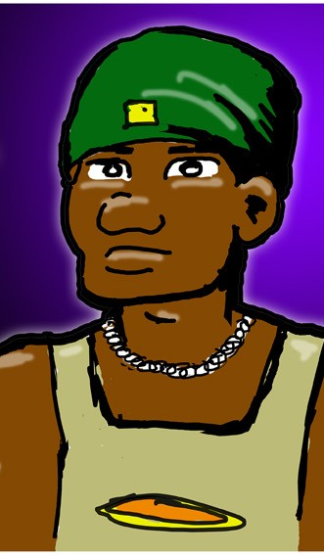To make an appointment or find out more …

3837 5633
(Biala)

3897 6330
(Redcliffe)

1800 177 833
(24 hr bookings/info/counselling)



Email:
hothouse@health.qld.gov.au

Our locations:

Biala
270 Roma Street
City QLD 4000
Phone: 3837 5633

Redcliffe
19 Creek Street
Redcliffe QLD 4020
Phone: 3480 4600

Hours of service:
9am – 5pm Monday – Friday

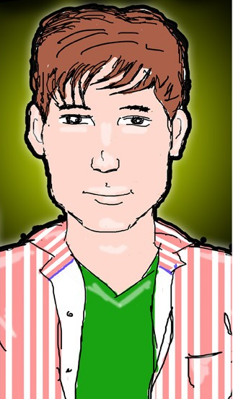

A free & confidential alcohol & drug service for people under 25

3837 5633
(Biala)

3897 6330
(Redcliffe)

1800 177 833
(24 hrs)

hothouse@health.qld.gov.au
BIALA – BRISBANE CITY REDCLIFFE
Youth Specialised Clinical Services
Metro North Mental Health –
Alcohol and Drug Service

